**CS691 - Computer Science, Fall 2022**

**Project Initiation Document**

Project: Health Plan

Project Manager: Tarun Dagar

Start Date: September 21, 2022

Completion Date:

Table of Contents

Document Purpose 4

Background to the Proposed Work 5

Vision 6

Project Objectives 6

Project Scope 6

Business Case 7

Assumptions 10

Constraints 10

Risk Management Strategy 11

Deliverables --

Stakeholders 12

Project Team 12

Project Plan 14

Project Controls 15

Communication Plan 15

Document Details

| Version | Modifications | Author | Date |
| --- | --- | --- | --- |
| 1 | Initial PID Document | PM | 09/25/2022 |
| 2 | Updated PID Document as per the feedback | PM | 09/30/2022 |
| 3 | Added Project Plan and RACI Table | PM | 07/10/2022 |
|  |  |  |  |

Approvals

This document requires the following approvals:

| Name | Role | Signature | Date | Version |
| --- | --- | --- | --- | --- |
| Tarun Dagar | Project Manager |  | 09/26/2022 | 1 |
| Riddhi Mhatre | Product Owner |  | 09/26/2022 | 1 |
| Vivek Karhale | Lead Business Analyst |  | 09/26/2022 | 1 |
| Sriharsha Mopidevi | Lead Developer |  | 09/26/2022 | 1 |
| Jigarkumar Patel | DBA |  | 09/26/2022 | 1 |
| Aliaksandra Paliashchuk | Lead QA Analyst |  | 09/26/2022 | 1 |
| Nishith Desai | Tester |  | 09/26/2022 | 1 |

Distrubutions

This document has been distributed to:

| Name | Role | Date of Issue | Version |
| --- | --- | --- | --- |
|  |  |  |  |
|  |  |  |  |
|  |  |  |  |
|  |  |  |  |

# Document Purpose

The main purpose of this project management document is to provide materials that can reference, and with which can prove that something was or was not done. After finishing a project, this reference documentation double-checks that the end product meets the quality standards and expectations set at the beginning. This documentation confirms that the project has met the client’s expectations. In this project documentation, gauge some valuable lessons about performance. The document will describe the Vision, Project Objectives, Project Scope, Business Case, Assumptions, Constraints, Risk Management Strategy, Deliverables, Stakeholders, Project Team, Project Plan, Project Controls, and Communication Plan related to the health plan through Web Application.

The Project initiation documentation should define the:

* Define the benefits and costs of the project and allocate resources with higher accuracy.
* Specifics about the strategy to be used for the project's Thought Web Application deployment. Depending on the particular needs of the project, employ a range of approaches. Reduce sometimes-overwhelming project work to more manageable, trackable activities.
* Evaluate performance and progress, and make sure to complete the project in time.
* Check if the requirements have been met, and plan to meet them.
* Reference change and risk documentation in case of disputes, scope creep, or other issues, to make resolution plans.
* Accurately communicate with all project stakeholders, including clients, management, and project team members.
* Assign task responsibilities and prioritize tasks with more accuracy.
* Prevent problems and/or hazards from affecting the project by identifying quality records, risks, project controls, and exceptions.

The document will be updated with the modifications. Every time a crucial decision is made about the project, the document will be consulted. The document will also be used to assess the project's management success at the end of the project and determine whether all deliverables were provided on time or not. This documentation also provides the team with a clear understanding of their responsibilities. By taking the time to document Team members performance and tasks, can ensure that their team can be aware of what is expected of them and can be successful in their Project. The sections of this document are dynamic and could potentially change over the lifetime of the project.

# Background to the Proposed Work

Do you disagree that the current, sedentary lifestyle we live has resulted in a number of serious health problems? In addition, we commonly hear people assert that the advancement of technology has considerably changed how people live nowadays. Have technological advances genuinely made your life simpler or more challenging? Unquestionably, NO is the correct response. No, technology has not made our life more difficult in any manner.

Unfavorable effects on health do exist. It has, however, offered many choices that much outweigh the drawbacks. It is possible to start working out at your desk directly in your office now, thanks to technological advancement. Many fitness mobile apps have been created as a result of technical advancements, which not only assist users improve their fitness levels but also help them maintain a healthy lifestyle. The popularity of creating a health and fitness app is increasing rapidly because of this. All that is required, if you genuinely want to be healthy, is the right prod from a reliable source. This enables you to adjust your way of life and daily routine, as necessary. Additionally, these Health plan apps are the greatest at offering a push in the right direction. You are kept focused and driven to reach the desired level of fitness by these. People have started taking their health and fitness more seriously in recent years. Because of this, the number of new gym members has significantly risen. As a result, fitness instructors have started to develop new workout plans. What about individuals who are unable to attend the gym because of their hectic schedules? Apps are the ideal answer for these people. Setting an unattainable goal early on can also be bad for your body and demotivate you from working out more. In this case, the use of health plan apps is crucial for creating a schedule with achievable goals. Only proceed to the following level after finishing the previous one. These apps assist users in maintaining an exercise regimen, which is one of the biggest obstacles for newcomers.

To create fitness and health apps with the features consumers want to help them maintain their fitness. An app for health and fitness is beneficial for everyone, novice, or fitness enthusiast alike. For those who cannot join a gym or afford to pay for expensive personal trainers, this fitness tracking software is helpful. You are given a routine to get the most out of your schedule by having all the information together. You get your butt off and keep moving because the routine is frequently fairly difficult to complete. While you are on an exercise program, it is important to eat well. However, every person has a unique body type and metabolism. A single diet plan cannot apply to all of them. Along with offering fitness suggestions, this app also provides dietary advice. Therefore, it advises you to eat so that you only take in a set quantity of calories. The erratic nature of modern living necessitates the flexibility that the apps offer. It is no longer necessary to go to the gym at a specific hour thanks to these apps. Based on all the details of your body, these applications plan out the exercises and regimen for you. All you have to do is take a break from your daily schedule and adhere to them as it suits you. As a result, the applications' magical powers are simply ruling the health and fitness sector. Go with the flow and have a healthy life. People who are overweight are helped by these apps to start a healthy exercise regimen.

# Vision

Tracking your progress towards achieving health goals is not an easy task, it is essential to plan it accordingly. HealthPlan is created with the goal of helping members reach their healthy lifestyle goals by supplying them with all the necessary tools for success. Our platform provides an easy and efficient way of tracking members’ fitness and diet goals as well as an opportunity to connect with professional fitness trainers and dietitians to help with achieving our members’ health goals even faster.

# Project Objectives

* To promote healthier and easier lifestyle
* To create an efficient and convenient tool that combines the functionalities of both fitness and diet tracking tools
* To add an opportunity for users to choose professional fitness trainers/dietitians
* To add an opportunity for professional fitness trainers/dietitians to find more customers
* To create a user-friendly interface for both parties, fitness trainers/dietitians and users working on their goals
* To partner with health/fitness brands and generate the platform’s profit

# Project Scope

* Provide a convenient and efficient way to track customers’ health and fitness goals as well as to connect trainers and dietitians to fitness enthusiasts
* User signup and Login to access the application
* Tracking both diet and fitness using the mobile application and third-party fitness tracking applications
* Payment gateway to authorize credit cards and direct payments
* Easy to use UI for best experience.
* Setup necessary Infrastructure for development and production

# 

# Business Case

| **Application Name** | **HealthPlan** |
| --- | --- |
| **Type of business model** | Brokerage/Advertising |
| **Target audience of external users**  **(Customer Segments)** | **For whom are we creating value?**  Fitness Trainers, Dietitians, Athletes, health, and fitness enthusiasts.  **Who are our most important customers?**  Health and fitness enthusiasts |
| **Groups of internal stakeholders and business users** | **Do we need a product development group?**  Yes, to build and develop the application/platform.  **Do we need a sales group?**  No, as we are not actually selling a product.  **Do we need a finance group (accounts payable, receivable)?**  Yes, to perform transactions between customers and fitness trainers and/or dietitians.  **Do we need a customer support team?**  Yes, in case of erroneous transactions/cancellations, applications failure.  **Do we need an advertising management group?**  Yes, for attracting customers and fitness trainers/dietitians to the platform. |
| **Value propositions** | **What value do we deliver to the customer?**  The main purpose of the platform is to provide a convenient and efficient way to track customers’ health and fitness goals as well as to connect trainers and dietitians to fitness enthusiasts  **Which one of our customers’ problems are we helping to solve?**   1. It will be solving the inconvenience of looking for a trainer/dietitian (providing a choice of virtual training vs real-life appointments) 2. Health tracking (uniting fitness and diet tracking under one platform for achieving health goals). 3. Help finding clients for Dietitians/Trainers   **What bundles of products and services are we offering to each Customer Segment?**  Trainer/dietitian: a product/platform that connects customers with trainers/dietitians' services (paid)  Health enthusiasts: a product/platform for health (fitness/diet) tracking (free) and convenient way to find and hire a trainer/dietitian (paid)  **Which customer needs are we satisfying?**   1. Trainers/dietitians’ needs to find customers 2. Health enthusiasts’ needs of tracking and taking control of their health and beauty |
| **Key resources** | **What Key Resources do our Value Propositions require?**   1. Design and development team to develop and maintain the application. 2. Content management team to manage the content and data set of the application. 3. Sales & Marketing team to attract health enthusiasts and onboard the Diet/Fitness experts. 4. Team of social and financial advisors for the needs of funding and exposure.   **Our Distribution Channels?**   1. Website 2. App Store 3. Social Media 4. Email Marketing   **Customer Relationships?**   1. Health enthusiasts: Rewarding the customers with points who use the application daily or are adding their data into the application. They can use these points to connect with the dietitians/trainers. 2. Trainers/dietitians: Helping them advertise themselves on our platform. Helping them attracts more clients.   **Revenue Streams?**   1. Convenience fee 2. Advertisement fee 3. Brand Partnerships to sell merchandise. |
| **How the system is used** | **What are the main system use scenarios for the External Customers?**   1. Fitness trainers and dietitians will use this application to offer their services to fitness enthusiasts. 2. Health enthusiasts will use this application to track their daily diet and their fitness activities. They can also connect to fitness trainers/dietitians. 3. Email Communication: We will use this to provide updates about new features, send newsletters and provide customer support.   **What are the main system use scenarios for the Internal Users?**   1. Reviewing Fitness/Dietitians’ applications 2. Advertisement management 3. Email Communication: For internal communication between teams. |
| **Revenue generation, Revenue streams** | 1. Convenience fee 2. Advertisement fee 3. Brand Partnerships to sell merchandise. |
| **Key Partners/Suppliers**  **(Stakeholders)** | Advertising Team (Bloggers), Health enthusiasts, Trainers/dietitians, Transactional Management. |
| **Expected Benefits to the Customer** | 1. Health enthusiasts can track their diet and fitness activities 2. They can book one-to-one appointments with their dietitians/trainer. 3. Trainers and dietitians can attract more health enthusiasts |
| **Known Prototypes** | 1. <https://www.healthifyme.com/us/> : A health and wellness which provides an app with services such as calorie tracking and advice on nutrition and fitness 2. <https://www.loseit.com/> 3. <https://www.strong.app/> 4. <https://www.medibuddy.in/> : This prototype is used for online/offline consultation, lab test appointments, medicine delivery, etc. |
| **Front-end Technology** | NextJS (React Framework) (HTML, CSS)  React native (Mobile Apps) |
| **Back-end, Database Technology** | Django, AWS (EC2, Lambda), PostgreSQL Database\ |

# Assumptions

| Assumption | Validated by | Status | Comments |
| --- | --- | --- | --- |
| Meeting | Project Manager | In Process | Project manager will schedule one – two meetings every week |
| Teamwork | Team Lead  Project Manager | In Process | Team Lead and Project manager will assign work to all team members |
| Skill Requirement | All Members | In Process | All members should cooperate on the programing works |
| Product Requirements | Product Owner | In Process | Product owners need to make sure that all the features are implemented as per the requirement. |

# Constraints

In this section, we describe things that will affect the Project and mean that you may not be able to meet the schedule. This can be anything from resources not being available due to unfamiliarity with a tool, problems with external product integrations, to any kind of team member issue affecting the launch of the project on the platform. date that is scheduled, in this project, we must take into account the limitations listed above:

Integrations: In this area we can find problems because external integrations that we will use in our app have several types of configurations, permissions and among other things to be integrated into our product. This leads to the need for a dedicated time to see how to achieve coupling to our product.

Technologies: We are currently working with technologies that can be beneficial for the product that we are creating, but these can be quite a complicated challenge for its development, due to the fact that there is a fairly small development team, and we are not expert with experience necessary to carry out the project in the proposed time.

Deadlines: It is true that the times are reflected from the beginning of the project and it is that the scope of this is not so extensive to be able to fight with the indicated times, but even so it is a quite complex challenge since it is about covering everything the due process for the development of the product and many members of the group have quite committed times since they are students and have other subjects. In this case, we must organize ourselves well in order to complete the deliverables in the stipulated time.

# Risk Management Strategy

|  |  |  |  |
| --- | --- | --- | --- |
| **Risk** | **Probability** | **Impact** | **Mitigation Method** |
| **Departure of teammate** | Low | High | All team members should get familiar with other members’ activities to be able to replace them in case of departure. |
| **Lack of development skills** | Low | High | All team members should start to practice development skills at early stage of the project. |
| **Project takes more time to finish than planned** | Low | Medium | Being organized with the project plan. Finish each activity before the deadline. If there is extra time, move to the next step as soon as possible. |

# 

# Stakeholders

This section will include a list of all known stakeholders and their interests in the project. It may be presented in the following format:

| Stakeholder | Interest |
| --- | --- |
| Advertising Team | Search resent growing health companies and offers and deals for showing advertisements for revenue. |
| Health enthusiasts | They invest money in health plans. |
| Trainers/dietitians | Trainers/dietitians will purchase shares or partnership. |
| Employers and Physicians | They invest money in health plans, buy shares. |
| Insurance Companies | Insurance companies sell health coverage plans directly to patients or indirectly through employers or governmental intermediaries. |
| Pharmaceutical firms | Medical equipment companies contribute to external stakeholders by manufacturing the medical equipment that physicians, surgeons, and medical staff use to help in the treatment of patients |
| Government | They invest money in health plans, buy shares and will provide free health care schemes for poor people. |

# Project Team

The project team includes the following roles

* Project Manager (Tarun Dagar)
* Product Owner (Riddhi Mhatre)
* Lead Developer (Sriharsha Mopidevi)
* Developer (Fernando Hernández)
* Business Analyst (Vivek Karhale)
* QA Lead (Aliaksandra Paliashchuk)
* DBA(Jigarkumar R Patel)
* Tester (Nishith Desai)

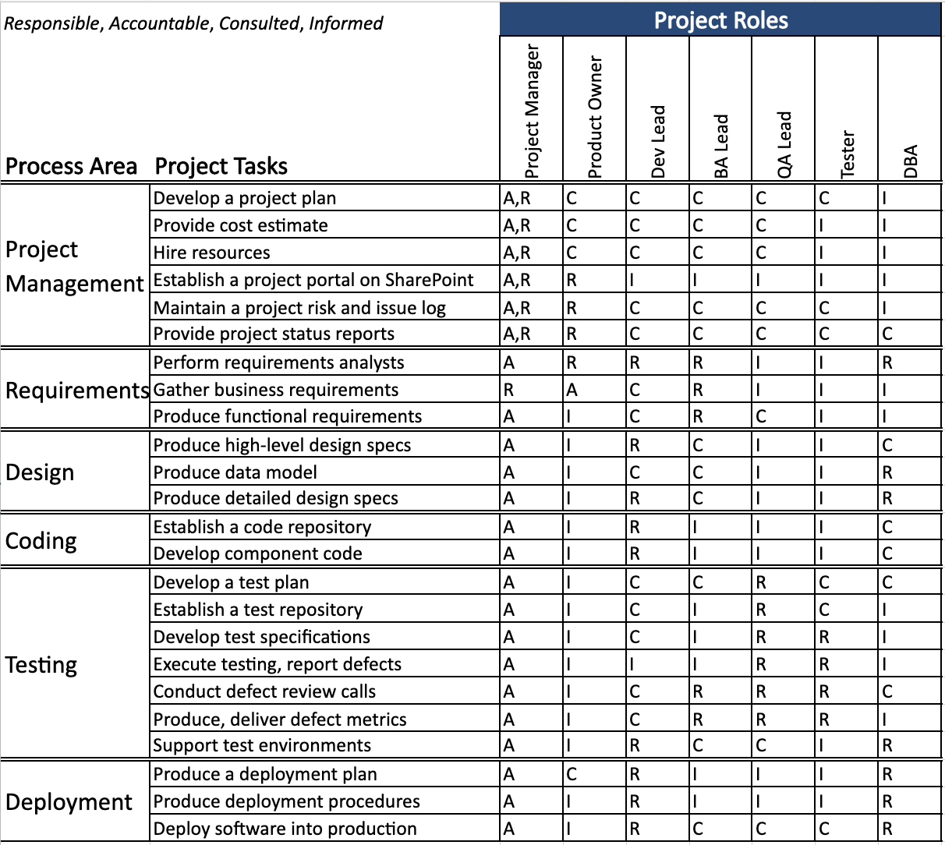

# Project Plan

This semester the project will follow the waterfall model divided into phases. This will help us to

create the MVP by the end of this semester.

Below are the 5 milestones:

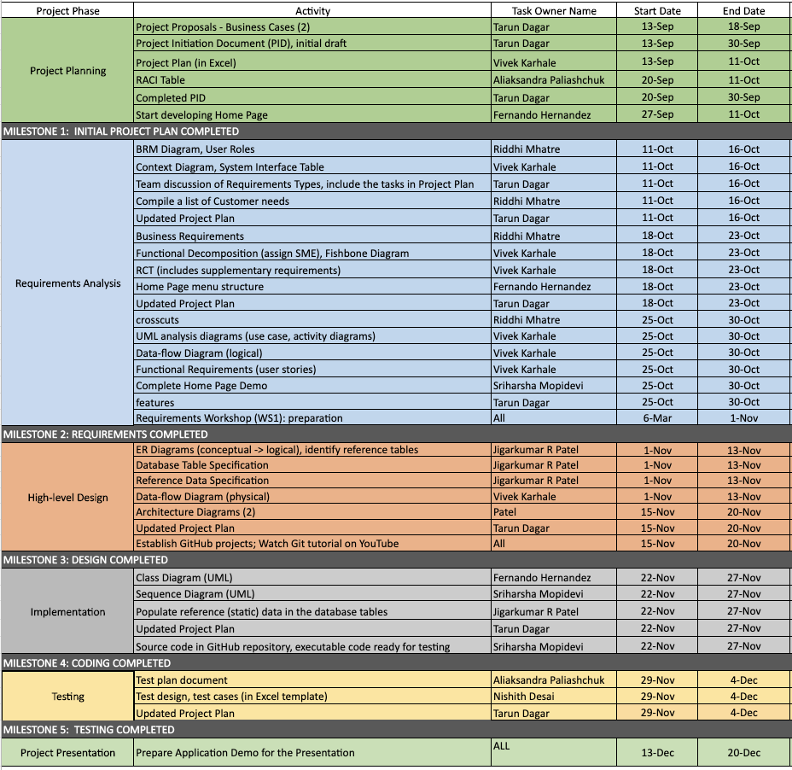

# Project Controls

All project aspects will be maintained in English, including, but not limited to, communications, documents, and source code.

Official meetings will be held at least once a week which is scheduled every Wednesday through remote video conferencing, in order to discuss progress, delegate tasks, and actively collaborate on project assets. If needed more meetings will be held accordingly. Methods of communication include Zoom for video conferencing, text by phone among team members, and Slack for team and professor communication.

Project documents will be kept and shared using Google G Suite productivity tools for remote access and ease of editing.

# Communication Plan

This section will include how stakeholders will be communicated with during the project and how frequently. This should include a note on where to find the Communications Plan if you have one.

| Stakeholder | Frequency | Type | Purpose |
| --- | --- | --- | --- |
| Professor | At key stages - meetings and deliverable drafts | Email/Slack | To approve Project implementation and direction. Advise if there are any potential issues. |
| Dietitians/Trainers | At key stages | Email, phone, personal meetings | To discuss the deliverables to health enthusiasts |
| Health enthusiasts | At key stages | Email, phone, personal meetings | To discuss problems faced by them for searching dietitians/ trainers, their requirements |
| Insurance/  Pharmaceuticals Companies/  Brand Partners | At key stages | Email, phone, personal meetings | To discuss the requirements to advertise and sell their product on our platform |
| Project Team | Daily | Email, Zoom for business, personal meetings, Slack | Maintain progress and ensure that the team is meeting weekly requirements. |
| End Users | Potentially during the testing phase and after release. | Email, online testing sessions, attend workshops for website | Feedback! |